Highlight

📘 Definition
# Source: AI Source: Provided by: [Data Path: Persons Table -> ID Column: 1, Name_En Column: Motasem Essam] -> From: [ChatGPT] on [5/2/2026]
A Highlight is the brightest spot on an object where light hits it most directly.

✨ How highlights are formed
# Source: AI Source: Provided by: [Data Path: Persons Table -> ID Column: 1, Name_En Column: Motasem Essam] -> From: [ChatGPT] on [5/2/2026]
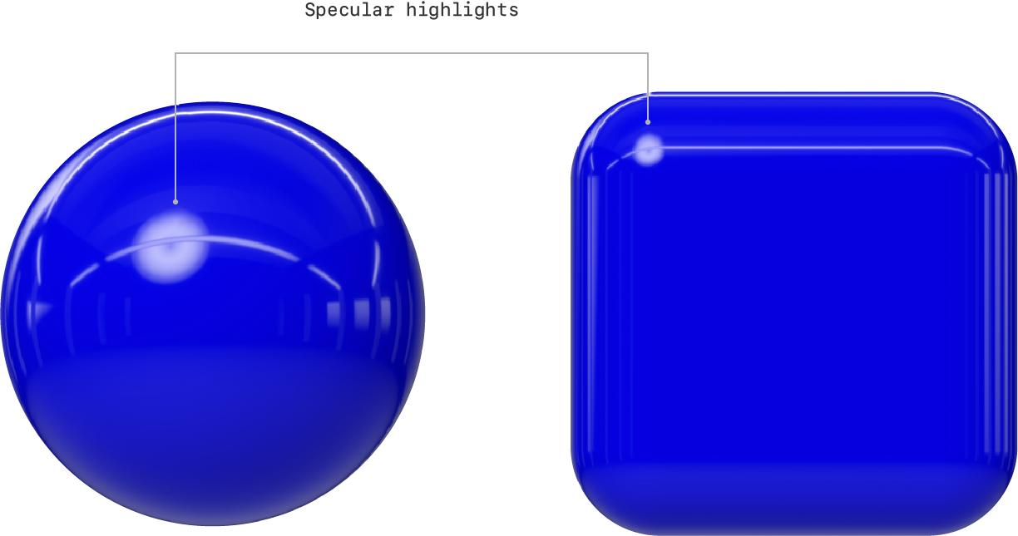
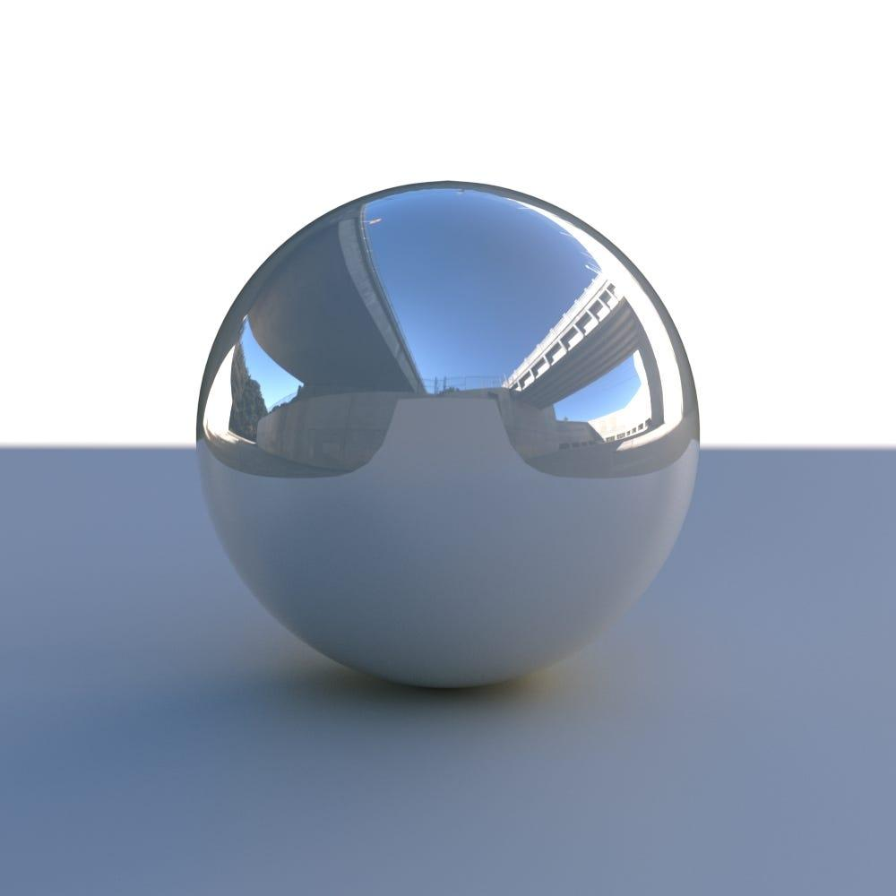

- Light comes from a light source
- It strikes the surface of an object
- The area that reflects the most light appears very bright → this is the highlight

🧠 Simple example
# Source: AI Source: Provided by: [Data Path: Persons Table -> ID Column: 1, Name_En Column: Motasem Essam] -> From: [ChatGPT] on [5/2/2026]
Think of:
- ✨ A shiny ball with a bright white spot
- 💧 Sunlight reflecting on water
- 🪞 Light hitting a mirror or metal surface

🎮 Highlight in computer graphics
# Source: AI Source: Provided by: [Data Path: Persons Table -> ID Column: 1, Name_En Column: Motasem Essam] -> From: [ChatGPT] on [5/2/2026]
Highlights are used to:
- Show shiny or glossy surfaces
- Indicate light direction
- Make objects look more realistic

⚙️ Key features
# Source: AI Source: Provided by: [Data Path: Persons Table -> ID Column: 1, Name_En Column: Motasem Essam] -> From: [ChatGPT] on [5/2/2026]
- 🌟 Brightest part of an object
- 📍 Located where light hits directly
- ✨ Stronger on smooth or shiny surfaces
- 🎯 Helps show shape and material

🚀 In short:
# Source: AI Source: Provided by: [Data Path: Persons Table -> ID Column: 1, Name_En Column: Motasem Essam] -> From: [ChatGPT] on [5/2/2026]
Highlight = the brightest area on an object where light reflects most strongly.

